**Project Description:**

The Paragon Devs App is a proposed freelance platform designed to support independent digital professionals in managing their client work, showcasing portfolios, and engaging in secure project transactions. This design emerged from the observed gap in existing freelance systems, which often lack customization, clarity, and user empowerment especially for new or non-technical freelancers. As digital freelancing continues to grow globally, there is a strong need for a streamlined, intuitive system that accommodates diverse freelance roles such as writers, designers, developers, and consultants.

**Requirements Summary:**

|  |  |  |
| --- | --- | --- |
| **MINIMUM**  **REQUIREMENTS** | Processor | Single Core 1.0 GHz |
| OS | Android 5.0 (Lollipop) API Level 21 |
| RAM | 2 GB |
| Storage | 200 MB available space |
| Network | Not required (offline functionality) |
| **RECOMMENDED REQUIREMENTS** | Processor | Quad Core 1.4 GHz |
| OS | Android 7.0 (Nougat) API Level 24 |
| RAM | 4 |
| Storage | 1.5GB available space |
| Network | Wi-Fi or mobile data (for cloud sync) |

Table 1. System Requirements

Paragon Devs App are the technical specifications needed for the app to function properly on Android devices.

**Prototype Description:**

Figma was used to develop the prototype. This is due to the fact that Figma is an interactive website and prototyping tool that developers may send to testers via links.

**Mock-up/Prototype:**

Onboarding Screen

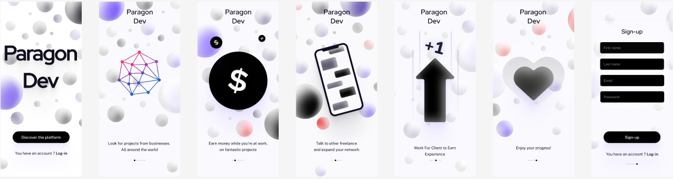

The Onboarding screen serves of Paragon Dev Simplistic and minimalist entry point, featuring the Information and about the app. "Discover" to see the feature in the app and below the Discover "Sign In" to redirect to the sign in menu. The design uses a simplistic design to be minimalist and esthetic theme with black theme to convey simplicity.

Log In/sign up

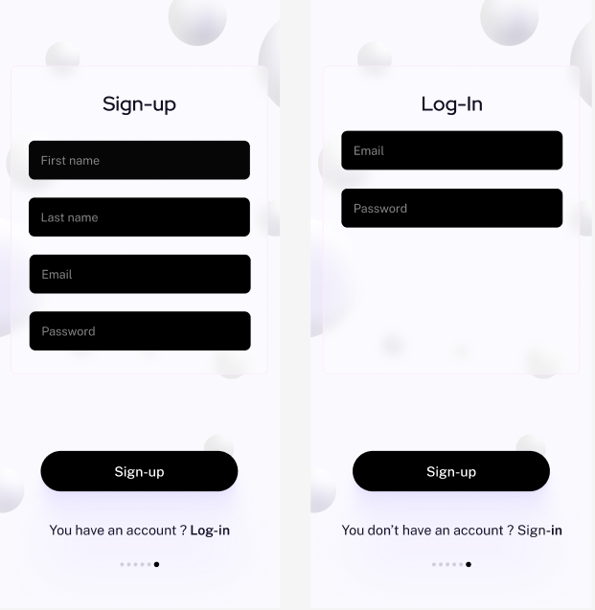

Paragon Dev’s login and sign-up screens feature clean, rounded input fields with minimalistic and simplistic, and friendly to user, and easy to use especially logging in and making an account.

Home

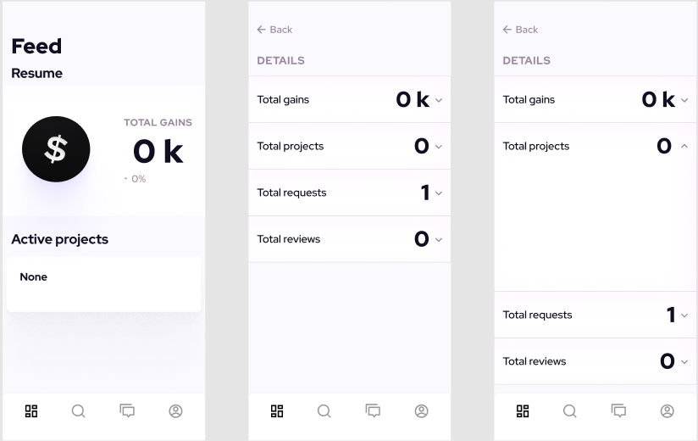

Paragon Dev's home screen features a dashboard with performance metrics like total gains, active projects, and client interactions, along with quick navigation to track earnings and project details.

Search Page/ Job posting

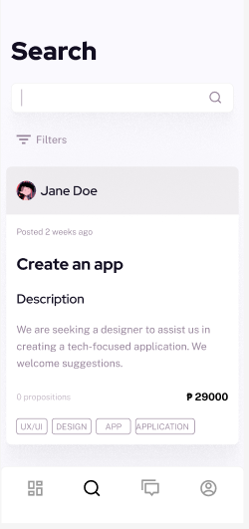

Paragon Dev’s  job listing where freelancers can view project details like the client's name Jane Doe, budget P29000, and description, along with an option to submit proposals currently 0 propositions. It includes search and filter tools to help freelancers find relevant opportunities.

Job Post

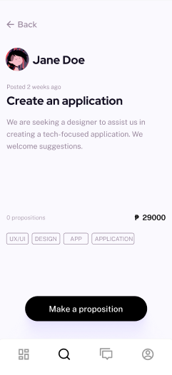

Paragon Devs screen displays a freelance job post where designers can view project details Create an application, client info Jane Doe, required skills UX/UI, DESIGN, and submit proposals Make a proposition. It highlights engagement metrics 0 propositions and encourages freelancers to bid on projects.

Profile Page

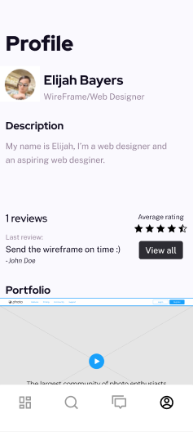

Paragon Devs features a profile screen showcases a freelancer's professional identity, displaying users skills, self-description, client reviews, and portfolio metrics. It serves as a personal branding hub for freelancers to highlight their expertise and feedback.

**Rationale:**

Because Figma is a free collaborative platform that facilitates simultaneous editing and simple sharing with faraway participants, the team decided to use it for developing the prototype. Figma facilitates rapid feedback integration and effectively displays the finished application design. However, drawbacks include scalability problems on larger screens where smaller buttons become challenging to use, reliance on the internet to save changes, and offline user entrapment. Notwithstanding these limitations, Figma offers more advantages for collaboration than disadvantages.  
  
**Figma Link**: <https://www.figma.com/design/FKAINUgyZc1SAn34QDJUD8/Paragon-Devs-Test?node-id=0-1&p=f&t=PdetW8vFrTGnaDnQ-0>

**Prototyping Tool:**we used Figma for prototyping, let me design, share, and test Paragon Devs in one place with interactive prototypes that mirrored the final app’s flow, all while collaborating in real time.

**User Scenario: Elijah Bayers, the freelancer**

Elijah Bayers, a freelance Wireframe/Web Designer, logs into his Paragon Devs profile to update his portfolio and check recent client feedback. He notices his last review from John Doe "Sent the wireframe on time and smiles, knowing punctuality strengthens his reputation. He updates his bio to reflect his growing expertise in UI/UX, then browses his averaging rating to track performance trends. Before applying for a new app design job listed on the platform, he quickly attaches his best portfolio samples, confident that his polished profile will attract high-quality clients.  
**Changes to the Requirements:**

The project's core requirements remained unchanged throughout development. While maintaining the original scope. The team voluntarily enhanced the UI/ design and wireframe structure to improve usability without altering scope. These optimizations focused on streamlining navigation, clarifying information hierarchy, and refining interactive elements. All changes maintained alignment with the project's core objectives while delivering a more polished user experience.

**Initial Evaluation Plan:**

**Usability Specifications:**Usability Specifications for the Paragon Devs freelancer app prototype, structured to ensure optimal user experience: **Efficiency**

* Users (freelancers/clients) can complete key tasks (browsing jobs, submitting proposals, managing profiles) in 3 steps.
* Search results load in 1 second with filters applied.

**Learnability**

* New users understand core functionality (Make a proposition) within 1 minute of onboarding.
* Icons/CTAs (UI tags, View Portfolio) follow platform conventions for instant recognition.

**Accessibility**

* Contrast ratios meet standards (text on buttons, review cards).
* Screen readers support all critical actions (job posts, profile edits).

**Error Prevention**

* Clear validation messages guide users when submitting proposals (character limits, file formats).
* Irreversible actions deleting projects require confirmation.

**Satisfaction**

Freelancers can update portfolios/reviews in 30 seconds.

**Test Participants:**  
5-10 participants:  
- Web design Freelancer  
- Programmer Freelancer  
- Artist Freelancer  
- Video Editor Freelancer  
-Clients

**Heuristic Evaluation (Nielsen’s 10 Principles):**

|  |  |
| --- | --- |
| **Heuristic** | **Application in Paragon Dev** |
| **Visibility of system status** | Clear deadlines and payment confirmations inform users, though loading indicators during uploads would help. |
| **Match to real world** | Natural messaging and industry terms |
| **User control and freedom** | Consistent Back buttons provide freedom, but adding proposal cancellation would enhance control. |
| **Consistency and standards** | Uniform CTAs work well, though table formats need standardization. |
| **Error prevention** | File uploads reduce errors, but character limits for proposals would prevent oversights. |
| **Recognition, not recall** | Visible skills and message history aid memory, while full project history would complete context. |
| **Flexibility and efficiency** | Quick upload file actions shine, saved templates could further speed repetitive tasks. |
| **Aesthetic, minimalist design** | Clean layouts highlight key data like budgets, though redundant "Back" buttons clutter tables. |
| **Error Recovery** | Read receipts confirm delivery, but error explanations like file size limits are missing. |
| **Help/documentation** | In-app guidance like payment alerts helps, while tooltips for terms like "Total gains" would add clarity. |